RAJALAKSHMI ENGINEERING COLLEGE
An Autonomous Institution, Affiliated to Anna University
Rajalakshmi Nagar, Thandalam – 602 105

WEB TECHNOLOGY AND MOBILE APPLICATION
Experiment – 05
2025-26

By
NIJANTHAN V
B-TECH AI&DS
2116241801185

Expt .NO: 05
Write a Servlet to demonstrate the difference between HTTP GET and POST methods by creating a form and handling requests accordingly
AIM:
To demonstrate the difference between the HTTP GET and POST methods by creating a form in an HTML page and handling the form submissions using two different HTTP methods in a Java Servlet.
ALGORITHM:
1. Input:
- The user fills out a web form with their name and email.
- The form will use both GET and POST methods for data submission.

2. Steps for Creating and Handling the HTTP GET and POST Requests:
- Create an HTML Form:
  - Design an HTML form with two input fields: one for the name and one for the email.
  - Create two buttons to allow the user to submit the form using GET or POST methods.
  - Use the action attribute to define the Servlet URL and specify the form method (either GET or POST).
- Create the Servlet to Handle GET and POST Requests:
  - Write a Java Servlet class that will handle both GET and POST requests.
  - The servlet will have two methods:
    - doGet() to handle the GET requests.
    - doPost() to handle the POST requests.
  - In both methods, retrieve the form data using request.getParameter().
  - In the doGet() method, process and display the data in the URL.
  - In the doPost() method, process and display the data in the HTTP request body.
- Handle GET Requests in the Servlet:
  - In the doGet() method, use request.getParameter() to retrieve the name and email submitted via GET.
  - Output the data as a response, including the name and email in the URL (visible to the user).
- Handle POST Requests in the Servlet:
  - In the doPost() method, use request.getParameter() to retrieve the name and email submitted via POST.
  - Output the data as a response, displaying the name and email without exposing them in the URL (more secure).
- Return the Output:
  - The Servlet should return an HTML page displaying the name and email entered by the user.
  - For the GET method, the output should be visible in the URL.
  - For the POST method, the output should be visible in the response body, not the URL.
- Deploy and Test the Servlet:
  - Compile the Servlet class and deploy it to a Servlet container (like Apache Tomcat).
  - Test the form using GET and POST methods to see the difference in data submission.
- Observe and Compare GET and POST Results:
  - Test the GET method: The form data is sent in the URL.
  - Test the POST method: The form data is sent in the HTTP request body, not visible in the URL.
CODE:
HTML Code:
<!DOCTYPE html>
<html>
<head>
<title>GET vs POST</title>
</head>
<body>
<h2>Demonstration of GET and POST</h2>

<form action="hello" method="get">
Name:
<input type="text" name="username" required><br><br>
<input type="submit" value="Submit using GET">
</form>

<br>

<form action="hello" method="post">
Name:
<input type="text" name="username" required><br><br>
<input type="submit" value="Submit using POST">
</form>
</body>
</html>

SERVLET Code:
package com;

import jakarta.servlet.*;
import jakarta.servlet.http.*;
import jakarta.servlet.annotation.WebServlet;
import java.io.IOException;
import java.io.PrintWriter;

@WebServlet("/hello")
public class HelloWorldServlet extends HttpServlet {

protected void doGet(HttpServletRequest request, HttpServletResponse response)
throws ServletException, IOException {

String name = request.getParameter("username");

response.setContentType("text/html");
PrintWriter out = response.getWriter();

out.println("<html><body>");
out.println("<h2>GET Method</h2>");
out.println("Name: " + name + "<br>");
out.println("Data is sent through URL");
out.println("</body></html>");
}

protected void doPost(HttpServletRequest request, HttpServletResponse response)
throws ServletException, IOException {

String name = request.getParameter("username");
response.setContentType("text/html");
PrintWriter out = response.getWriter();

out.println("<html><body>");
out.println("<h2>POST Method</h2>");
out.println("Name: " + name + "<br>");
out.println("Data is sent through request body");
out.println("</body></html>");
}
}

OUTPUT:
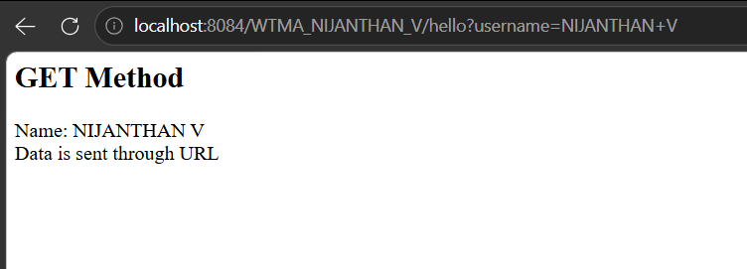
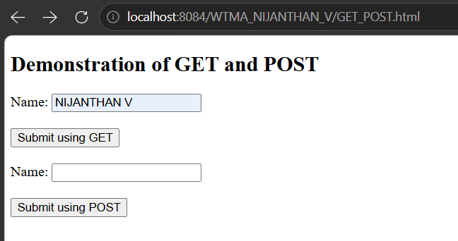
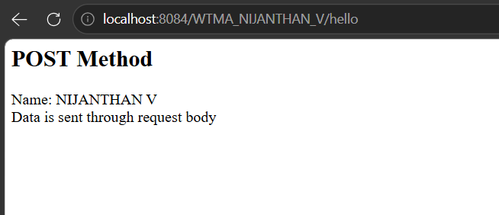
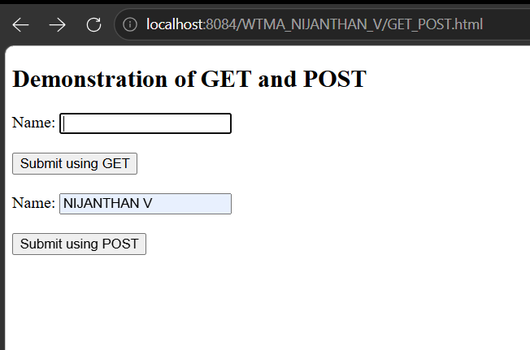

RESULT:
A Servlet is created to demonstrate the difference between HTTP GET and POST methods by creating a form and handling requests accordingly.

